General Information
- Scientific name: Pavo cristatus
- Family: Phasianidae (same family as pheasants)
- Native range: Indian subcontinent — found across India, Sri Lanka, and parts of Myanmar.
- National bird of India: Symbolizes grace, pride, and beauty.
Natural Habitat
- Prefers open forests, farmlands, and grasslands near water sources.
- Commonly seen in semi-dry regions and village outskirts where food and shelter are abundant.
- Roosts on tall trees at night to stay safe from predators.
Food Habits
Peacocks are omnivorous:
- Plant-based: Seeds, grains, fruits, berries, and tender shoots.
- Animal-based: Insects, small reptiles, frogs, and even snakes.
- They help control pests in agricultural areas — a natural benefit to farmers.
Colors and Appearance
Behavior and Breeding
- Breeding season: Monsoon months (June–September).
- Males perform elaborate dances and calls to attract females.
- Females lay 3–6 eggs in shallow ground nests.
- Chicks can walk and feed themselves within hours of hatching.
Availability and Conservation
- Widely distributed across India, Sri Lanka, and introduced in Africa, Australia, and U.S. parks.
- Protected under Schedule I of the Indian Wildlife Protection Act, 1972.
- Threats include habitat loss and illegal hunting for feathers, though populations remain stable in many regions.
Cultural Significance
- Associated with Lord Krishna and Goddess Saraswati in Indian mythology.
- Represents beauty, immortality, and spiritual awakening in many cultures.
- Its feathers are often used in art, decoration, and traditional rituals.
Below table shows how many peacocks available on each country
country | peacock count
Portugal | 10
Spain | 10
India | 500
Australia | 55
UAE | 10
UK | 10
Above table shown how many peacocks available on each country

Below table shows the incharge of animals based on every country
Incharge name | Department | Country
Jeyaseelan | Central Animal Welfare | Portugal
Purus | Anilmal Husbandry | Spain
Rishi | Anilmal Welfare | UK
Liokios | Animal Safety | UAE

above table shows the incharge of animals based on every country

the below picture is about the dancing peacock
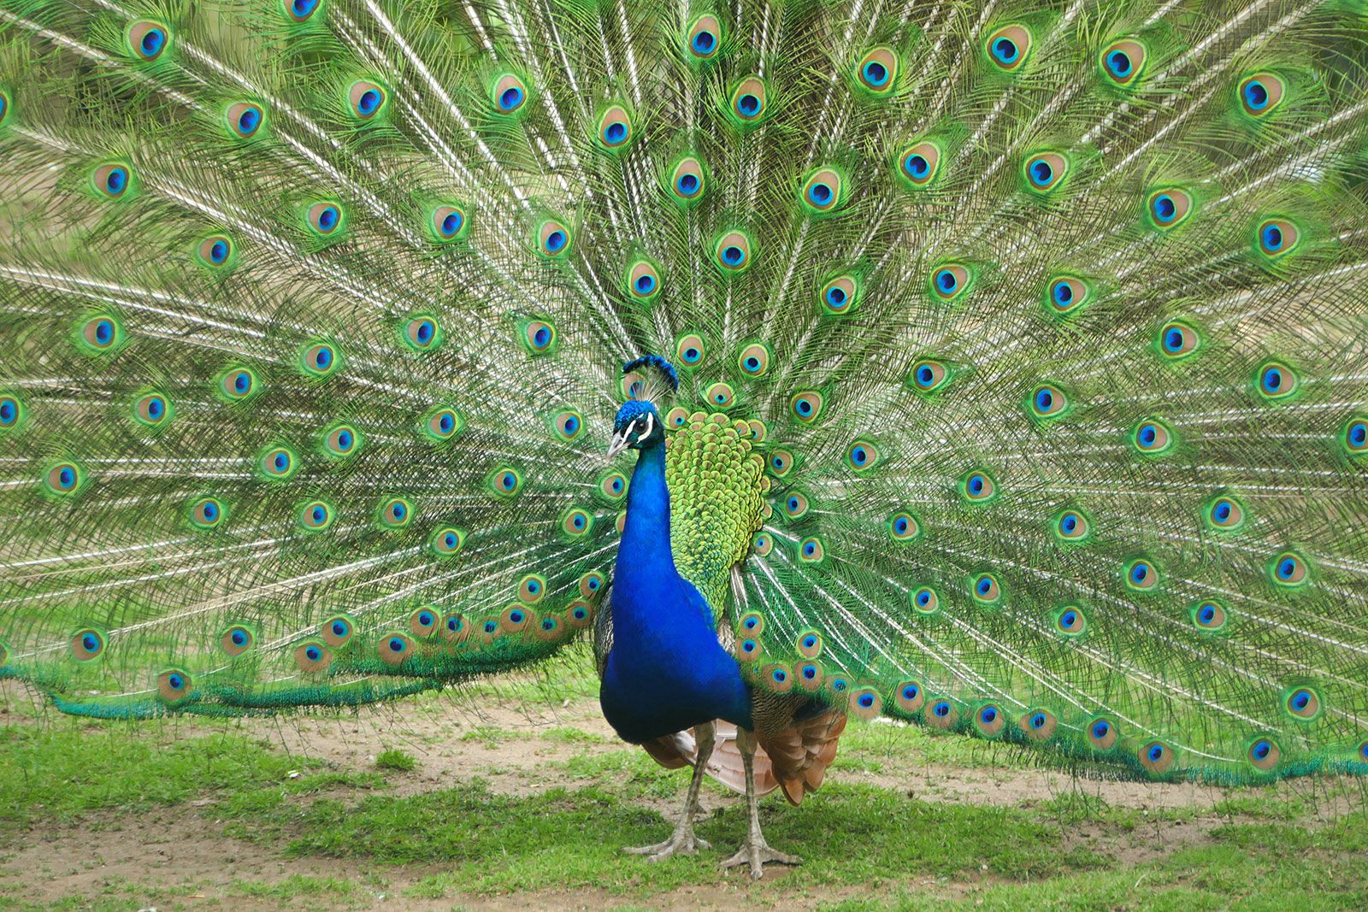
Figure 1dancing peacock
the above picture is about the dancing peacock
below is the picture of peacock drew by hand/pencil
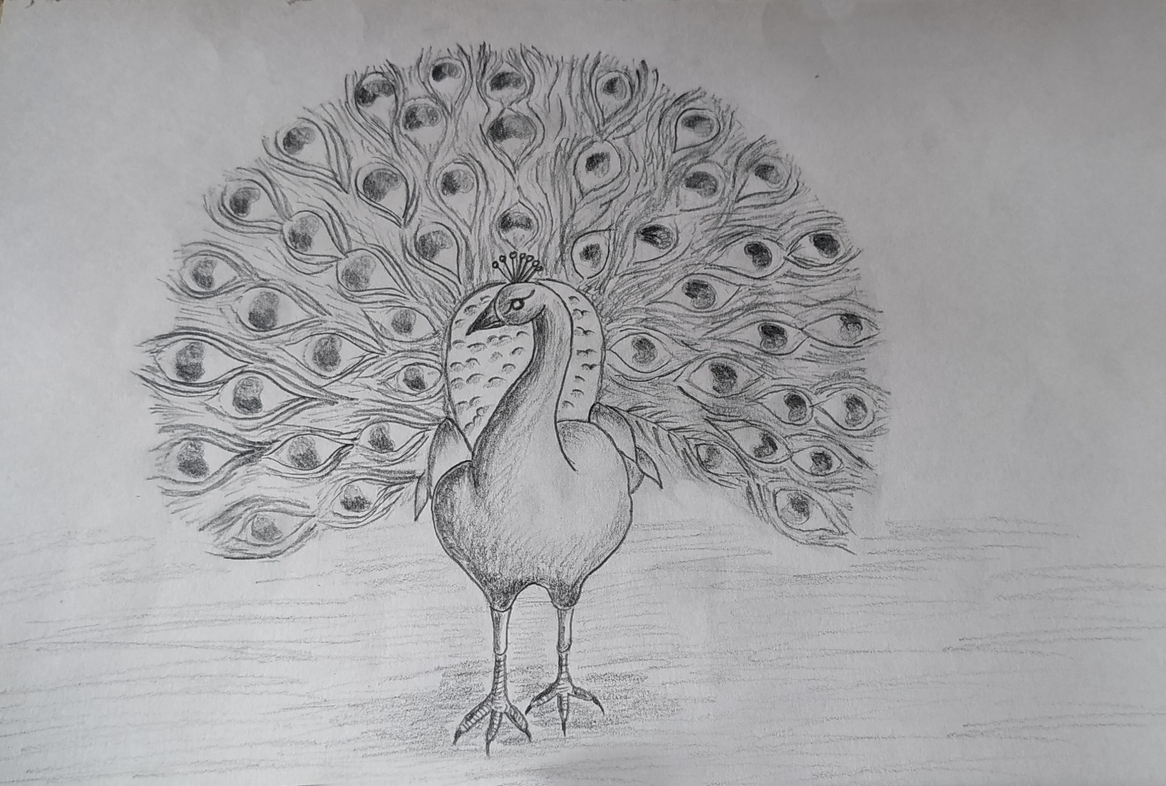
Figure 2peacock drew by hand or pencil
above is the picture of peacock drew by hand/pencil

